EXP NO: 8 (version 2)
MODEL EVALUATION AND IMPROVEMENT: HYPERPARAMETER TUNING WITH GRID SEARCH AND CROSS-VALIDATION

AIM
To evaluate and improve a machine learning model using Grid Search for hyperparameter tuning and K-Fold Cross-Validation to obtain reliable model performance and reduce overfitting.

PROCEDURE
- Load the Iris dataset.
- Divide the data into training and testing sets.
- Normalize the feature values.
- Define different SVM hyperparameters.
- Perform Grid Search using 5-fold validation.
- Test the optimized SVM model.
- Perform K-Fold Cross-Validation.
- Display the accuracy results graphically.

CODE
import numpy as np
import matplotlib.pyplot as plt
from sklearn.datasets import load_iris
from sklearn.model_selection import train_test_split, GridSearchCV, KFold, cross_val_score from sklearn.pipeline import Pipeline
from sklearn.preprocessing import StandardScaler from sklearn.svm import SVC
from sklearn.metrics import accuracy_score, confusion_matrix, ConfusionMatrixDisplay data = load_iris()
X = data.data y = data.target

X_train, X_test, y_train, y_test = train_test_split( X, y, test_size=0.25, random_state=7, stratify=y
)

pipeline = Pipeline([
("scaler", StandardScaler()), ("svm", SVC())
])

parameters = {
"svm C": [0.5, 1, 5, 20],

"svm gamma": ["scale", 0.1, 0.01],
"svm kernel": ["rbf", "linear"]
}
search = GridSearchCV( pipeline,
parameters, cv=5,
scoring="accuracy"
)

search.fit(X_train, y_train)

print("Best Parameters:") print(search.best_params_)

print("Best Cross-Validation Accuracy:") print(round(search.best_score_, 4))

best_model = search.best_estimator_ predictions = best_model.predict(X_test) accuracy = accuracy_score(y_test, predictions) print("Test Accuracy:", round(accuracy, 4)) matrix = confusion_matrix(y_test, predictions)
ConfusionMatrixDisplay( confusion_matrix=matrix, display_labels=data.target_names
).plot()

plt.title("Confusion Matrix - Optimized SVM") plt.show()

kf = KFold( n_splits=5, shuffle=True, random_state=7
)

scores = cross_val_score( pipeline,
X,
y, cv=kf,
scoring="accuracy"
)

print("Cross-Validation Scores:") print(np.round(scores, 4))

mean_score = scores.mean() std_score = scores.std()

print("Mean Accuracy:", round(mean_score, 4)) print("Standard Deviation:", round(std_score, 4))
plt.figure(figsize=(7, 5)) plt.plot(
range(1, 6), scores, marker="o"
)
plt.axhline( mean_score, linestyle="--",
label=f"Mean = {mean_score:.4f}"
)
plt.xticks(range(1, 6)) plt.xlabel("Fold Number") plt.ylabel("Accuracy")
plt.title("5-Fold Cross-Validation Results") plt.legend()
plt.show()

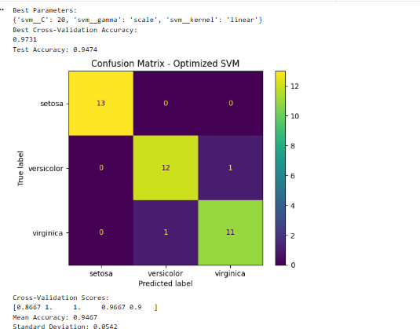
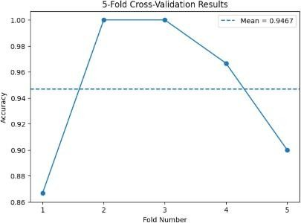
OUTPUT:

RESULT
The SVM classifier was successfully optimized using Grid Search and evaluated using 5-Fold Cross-Validation. The best hyperparameter combination was obtained automatically, and the model showed good classification accuracy on the Iris dataset

